Software/Frameworks Research —

Onboarding FAQ & Request Tracking

Project: AI Assistant for HR

Task: Research software/frameworks for the onboarding FAQ and HR service request tracking approach
Role: Dev
Sprint 1 – Week 2

Deliverable: Framework/tooling options for onboarding FAQ answering and request-status tracking, a recommended MVP stack, and cost/risk notes
Prepared by: Minh Quang Tran (s4089848)

TL;DR (create with help from Claude)
- FAQ: Vercel AI SDK (chat) + Firestore native vector search + Genkit embeddings extension. Skip LangChain/LlamaIndex — approved-doc set is too small to justify them.
- Tracking: Firestore status field (submitted → in_progress → completed / escalated) + transition map + the existing useCollection hook for realtime. No ticketing tool needed.
- Escalation: tiered confidence (answer / caveat / escalate) + a hard-coded restricted-topic override, shared by both use cases.
- Proof it works: loanDepot’s Microsoft Teams assistant cut IT approvals from days to under 5 minutes.
- Cost: fits Firestore’s free tier; LLM API calls are billed separately, per token, regardless of provider.
- Requirements check: fully covers FAQ + checklist + tracking + escalation. Doesn’t cover request submission/classification/routing or “clear feedback” — outside this doc’s named scope, not a gap in what was researched.

Requirements Check (create with help from Claude)
Each functional requirement from the BA requirements doc (new_V-BA-gather requirements.docx), checked against whether the research below actually addresses it.

Employee Onboarding
Requirement | Addressed? | Where / note

Answer onboarding question | Covered | Chat/streaming layer (Vercel AI SDK) is exactly this  transport.
Use approved HR information | Covered | Firestore vector search + Genkit embeddings restrict answers to the approved-  document collection.
Onboarding Checklist (display task + status) | Covered | Checklist lane in the process diagram — a per-employee Firestore doc (task + status)  read live via useCollection.
Outstanding tasks | Covered | Same Firestore checklist doc; the status field is what the checklist screen uses to separate completed from  outstanding.
Unsupported questions | Covered | Escalation Pattern section —  low-confidence / no-match questions escalate.
Human Escalation | Covered | Escalation Pattern section.

HR Service Requests
Requirement | Addressed? | Where / note
Submit request | Not covered | No framework/tooling  discussed for the intake step itself.
Identify request category | Not covered | No classification approach  discussed.
Collect required information | Not covered | No discussion of multi-  turn/slot-filling collection.
Request confirmation | Not covered | No discussion of an echo-  back-before-submit step.
Route request | Not covered | Tracking Approach covers status after routing, not the  routing decision itself.
Request status | Covered | Tracking Approach section — status field + transition map  + realtime read.
Unsupported/sensitive  requests | Covered | Escalation Pattern section —  restricted-topic override.
Escalation | Covered | Escalation Pattern section.

Shared MVP Requirements
Requirement | Addressed? | Where / note

Approved information | Covered for onboarding | Not extended in the research to HR Service Request  classification/routing.
Uncertainty handling | Covered | Confidence-tier design in the  Escalation Pattern section.
Human escalation | Covered | Escalation Pattern section.
Escalation visibility | Covered | The research requires the handoff itself to be visible to  the employee.
No sensitive decision-making | Covered | Restricted-topic override,  cross-referenced against the out-of-scope lists.
Clear feedback | Not covered

The remaining gaps are the HR Service Request
submission/classification/collection/confirmation/routing steps and the general “clear feedback” UX pattern — neither of which were part of the onboarding-focused task this research set out to cover.

Purpose
The Sprint 1 Week 2 requirements document (new_V-BA-gather requirements.docx) sets functional requirements for two MVP use cases: Employee Onboarding — answer approved-info onboarding questions, show a checklist, escalate unsupported questions — and HR Service Requests — submit, classify, collect missing information, confirm, route, expose status, and escalate. This document surveys the software and design patterns that could satisfy those two requirement areas, so a concrete MVP stack can be chosen before implementation starts.
It focuses on two sub-problems named in the requirements: answering onboarding FAQs from approved information (the “Use approved HR information” functional requirement), and
tracking the status of a submitted HR service request (the “Request status” functional requirement). A third, shared pattern — human escalation — is covered separately because both use cases depend on it.

Onboarding FAQ & Checklist — Process Diagram
Two flows power an onboarding assistant: answering a question, and keeping the checklist in sync. Both stay inside approved information — the FAQ flow escalates rather than guesses, and the checklist flow only ever reflects what HR has actually set.

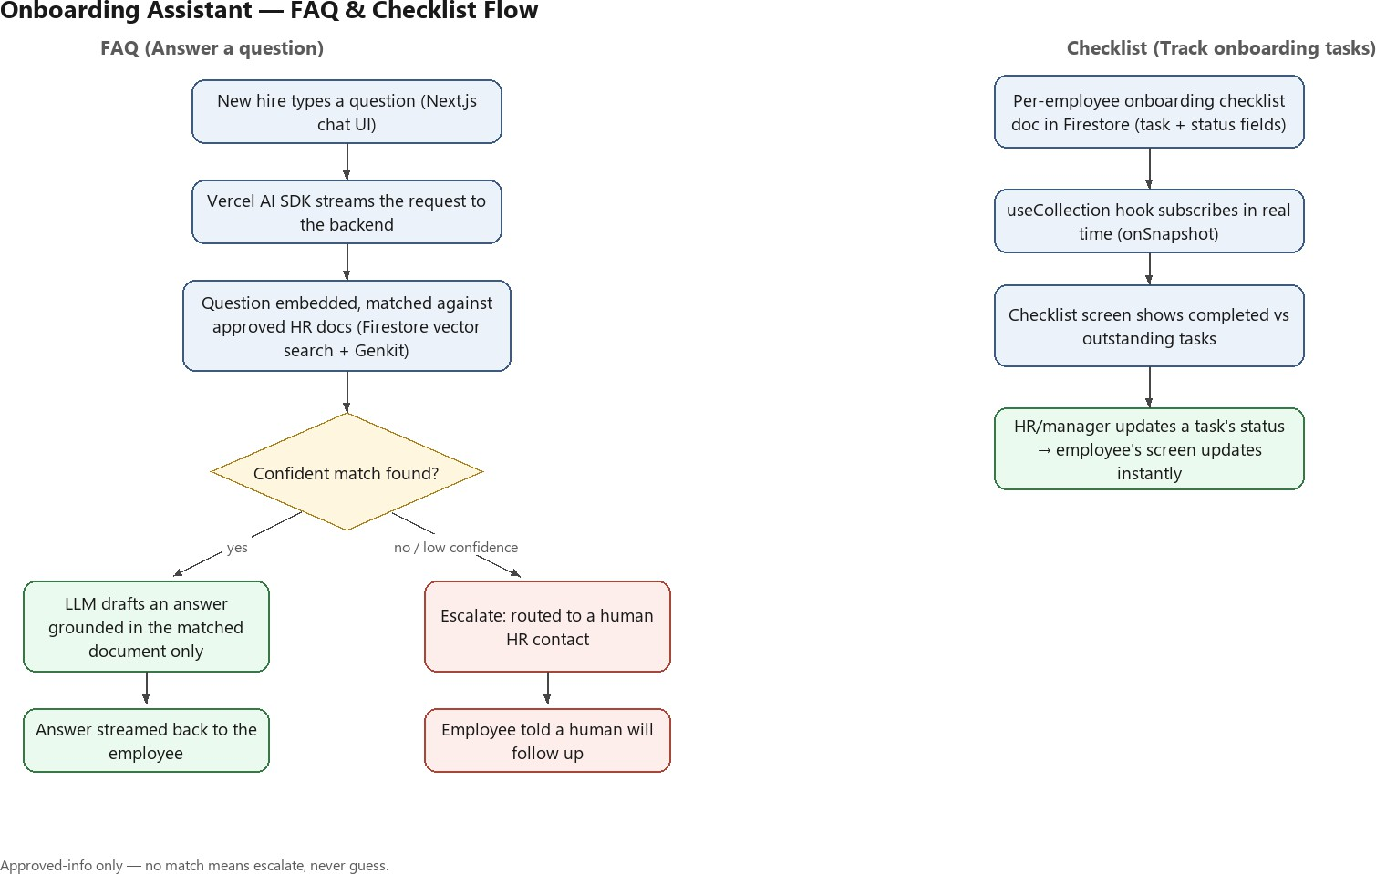

Onboarding FAQ & Checklist — Software, Libraries & Resources
Answering onboarding questions “using approved HR information available to the system” is a retrieval-augmented generation (RAG) problem: retrieve the relevant chunk of an approved document, generate an answer grounded in it, and detect when nothing relevant exists so the assistant escalates instead of guessing — directly matching the “Unsupported questions” requirement. The checklist is a simpler, separate problem: a per-employee record of tasks and their status, kept in sync in real time.

Software / Library /  Resource | Type | How it applies here
Vercel AI SDK | npm library | Powers the chat UI where a new hire types a question — streams the reply token-by-token and can swap the underlying model provider  without a rewrite.
Firestore native vector search | Firebase/Firestore feature (GA) | Stores approved onboarding documents as a normal Firestore collection and finds the closest match to a question by meaning, not just keywords  — no second database.

Firebase Genkit + Vector Search extension | Firebase extension | Auto-computes and refreshes the embedding on a document whenever it is added or edited, removing the need for a hand-  built embeddings pipeline.
LLM provider API (e.g.  Gemini/Claude/Open AI) | External API | Reads the matched document and drafts the answer in plain language — instructed to answer only from what was  retrieved, nothing else.
Firestore per-employee checklist doc + useCollection hook | Firestore doc + existing repo hook (frontend/src/hooks/useFirestore. ts) | Holds each onboarding task and its status; the hook subscribes in real time so a status change by HR appears on the  employee’s screen instantly, no  refresh.
Typed Firestore collections (get{X}Collection() pattern) | Existing repo convention (frontend/src/lib/firebase/firestor e.ts) | A new getHrPoliciesCollection() and getOnboardingChecklistCollecti on() would follow the same typed pattern already used for users, keeping both features consistent with the rest of the  codebase.
LangChain / LlamaIndex | npm libraries (considered, not adopted) | Would orchestrate retrieval-then-generate for you, but the approved-document set here is small and fixed — querying Firestore’s vector index directly is simpler than learning either  framework for this scale.

Onboarding FAQ — Framework Options
A closer look at the four pieces used to answer a question, and why each one was or wasn’t adopted:

Layer | Options considered | Notes
Chat UI / streaming | Vercel AI SDK vs. a hand-rolled fetch/SSE implementation | Vercel AI SDK ships streaming responses, tool calling and 25+ model providers out of the box, and is built for the Next.js App Router this repo  already uses.

Retrieval / indexing framework | LlamaIndex vs. LangChain vs. no framework (query Firestore directly) | LlamaIndex reaches a working retrieval pipeline in fewer lines but hides more detail; LangChain gives finer control at a steeper learning curve and a heavier client  bundle (~101 kB gzipped).
Vector store | Pinecone / Upstash Vector / Supabase pgvector vs.  Firestore native vector fields | Firestore vector search (K-nearest-neighbour, GA) supports hybrid queries — similarity plus normal where filters — without standing up  a second database.
Embeddings pipeline | Manual embedding calls vs. Firebase's Genkit + Vector Search extension | The extension auto-computes and stores an embedding on a Firestore  field via Gemini, orchestrated through Genkit flows.

Chat / streaming layer
The Vercel AI SDK is the natural fit for the Next.js frontend already in this repo: it handles token streaming, structured tool calls, and swapping model providers without committing to a specific LLM vendor. It does not do retrieval itself — it is the transport/UI layer that would sit in front of whichever retrieval approach is chosen below.

Retrieval & indexing framework
LangChain is a general orchestration framework for chaining LLM calls, tools and multi-step agents; LlamaIndex is narrower and focused on indexing and retrieval, which makes it faster to reach a working document Q&A pipeline. For this MVP, the approved-information set is small and fixed (onboarding policies, checklist definitions), which is exactly the case where neither framework may be needed — querying Firestore’s vector index directly keeps one fewer dependency and one fewer abstraction to reason about. LangChain remains the better choice if the assistant later needs to call multiple tools or data sources as part of one answer, not just retrieve text.

Vector store & embeddings pipeline
Firestore now supports vector fields and K-nearest-neighbour search as a generally-available, native feature — including hybrid queries that combine vector similarity with ordinary Firestore filters (e.g. only search policies published in the last quarter). Google's Genkit-based Firebase extension automates the embeddings half: it computes and writes an embedding to a Firestore document field whenever that field changes, using Gemini as the embedding model. Combined, this means approved HR documents can be stored as a normal typed Firestore collection

(following this repo's existing get{X}Collection() pattern) with an embedding field attached, and answered against with no separate vector database.

Checklist storage & realtime sync
The onboarding checklist doesn’t need any of the retrieval tooling above — it’s a plain per-employee Firestore document (or subcollection) with one entry per task, each carrying a status field (e.g. completed / pending). The existing useCollection hook (onSnapshot-based, already in this codebase) subscribes to that document so the “Onboarding Checklist” and “Outstanding
tasks” requirements are both satisfied by the same read: the checklist screen renders every task, and outstanding ones are just the entries whose status isn’t completed. When HR or the system marks a task done, every employee viewing their checklist sees it update without a page refresh.

Tracking Approach — HR Service Request Status
The “Request status” requirement (submitted → in progress → completed) and the edge case “Request status is unavailable → inform the employee rather than showing an incorrect status” both point to a status state machine rather than a general-purpose ticketing product (Zendesk, Freshservice) that would be over-scoped for an MVP.

Status | Meaning | Set by
submitted | Request accepted; required  information collected and confirmed | Assistant, after employee confirmation
in_progress | Routed to a specialist/team  and being actioned | HR/specialist team
completed | Resolved; employee notified | HR/specialist team
escalated | Flagged as unsupported or  sensitive; routed to a human | Assistant, on an escalation  trigger

The pattern is a status enum field plus a valid-transition map (e.g. submitted → in_progress or escalated; in_progress → completed or escalated), enforced inside a Firestore transaction so a request can never skip a state or be updated by two actors at once. Because the boilerplate already has frontend/src/hooks/useFirestore.ts's useCollection hook (onSnapshot-based), an employee's “check my request” view gets realtime status updates for no additional infrastructure — the same collection write that moves a request to in_progress is what the employee's screen reflects.

Escalation Pattern (shared by both use cases)
Both use cases require escalating to a human rather than guessing or auto-processing. The common industry pattern is a tiered confidence threshold combined with hard overrides for restricted topics, so a topic like a workplace complaint or a salary change is escalated regardless of how confident the model is:

- High confidence (roughly above 0.8): answer directly from approved information.
- Medium confidence (roughly 0.5–0.8): answer with a caveat and offer a human contact.
- Low confidence (below roughly 0.5): escalate rather than answer.
- Restricted-topic override: complaints, pay/salary changes, disciplinary matters, and workplace-relationship issues escalate regardless of confidence — matching this project's out-of-scope lists for both use cases.
- Non-confidence triggers: an explicit request for a person, or the same question/answer repeating without resolution.
Whichever threshold is used, the “Escalation visibility” shared requirement means the handoff itself must be visible to the employee — a clear message that a human has been looped in, not a silent redirect.
One public example worth a look: loanDepot’s Moveworks-powered assistant, deployed in Microsoft Teams, cut new-hire IT approvals from days to under five minutes (Moveworks, n.d.).

Recommended Stack for MVP
- Frontend: existing Next.js App Router + Vercel AI SDK for the chat UI and streamed responses.
- Retrieval: Firestore native vector search over a typed HR-content collection, with the Firebase Genkit embeddings extension keeping embeddings in sync — no LangChain/LlamaIndex and no separate vector database for MVP scope.
- Tracking: a status-enum + valid-transition-map pattern on the HR service request collection, written inside Firestore transactions and read in real time via the existing useCollection hook.
- Escalation: a tiered confidence threshold plus a hard-coded restricted-topic list, applied to both onboarding questions and service requests, with an explicit escalation message shown to the employee.
This reuses existing repo conventions (typed Firestore collections, Server Actions returning ActionResult<T>, the useCollection hook) rather than introducing a second backend framework, which keeps the MVP within the boilerplate’s zero-Docker, zero-emulator setup.

Cost & Risk Considerations
- Firestore's free tier (Spark plan) allows 1 GiB storage, 50,000 reads/day and 20,000 writes/day; vector search queries are billed the same as normal reads (100 vector-index entries scanned ≡ 1 read), so MVP-scale usage should stay within the free tier.
- Composite/vector indexes are capped at 200 without billing enabled and 1,000 with the Blaze plan — unlikely to be a constraint for a handful of onboarding/service-request collections at MVP scope, but worth re-checking if the schema grows.

- LLM API calls (embeddings and answer generation, whichever provider is chosen) are billed per token by that provider, separately from any Firebase plan — a cost to budget for regardless of which vector store is used.
- LangChain/LlamaIndex add a real dependency and their own abstractions; for a small, fixed set of approved HR documents that cost may not be justified — worth prototyping against Firestore’s native vector search directly before adopting a framework.

References — APA 7th edition
- DataStax. (n.d.). Build a RAG chat app with Firebase Genkit and Astra DB. DEV Community. https://dev.to/datastax/build-a-rag-chat-app-with-firebase-genkit-and-astra-db-31n1
- Firebase Developers. (n.d.). Implementing RAG with Firebase Genkit. Medium. https://medium.com/firebase-developers/title-implementing-rag-with-firebase-genkit-82cfde11a384
- Google Cloud. (n.d.). Get started with Firestore vector similarity search. Google Cloud Blog. https://cloud.google.com/blog/products/databases/get-started-with-firestore-vector-similarity-search
- Google Cloud. (n.d.). Search with vector embeddings. Google Cloud Firestore Documentation. https://docs.cloud.google.com/firestore/native/docs/vector-search
- Google Cloud. (n.d.). Quotas and limits. Google Cloud Firestore Documentation. https://docs.cloud.google.com/firestore/quotas
- Firebase. (n.d.). Usage and limits. Firebase Documentation. https://firebase.google.com/docs/firestore/quotas
- Strapi. (n.d.). LangChain vs Vercel AI SDK vs OpenAI SDK: 2026 guide. Strapi Blog. https://strapi.io/blog/langchain-vs-vercel-ai-sdk-vs-openai-sdk-comparison-guide
- Vercel. (n.d.). LlamaIndex vs. LangChain: How to choose the right framework. Vercel. https://vercel.com/i/llamaindex-vs-langchain
- Google Cloud. (n.d.). Workflows state management with Firestore. Medium. https://medium.com/google-cloud/worklows-state-management-with-firestore-99237f08c5c5
- Twig. (n.d.). How AI escalates to humans (3 real triggers). Twig Blog. https://www.twig.so/blog/how-does-ai-know-when-to-escalate-to-human-agent
- eesel AI. (n.d.). How to set up an AI agent that escalates to a human when unsure. eesel AI Blog. https://www.eesel.ai/blog/ai-chat-escalation
- Moveworks. (n.d.). 5-minute IT approvals? loanDepot says yes with Moveworks. Moveworks. https://www.moveworks.com/us/en/customers/loandepot-automates-approvals-with-moveworks

